Letter to Teachers
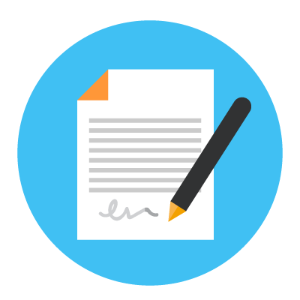
Purpose:
To communicate important things about you to your teachers and other adults at school when you return to school (The best way for them to know how to help you best is to hear it from you!)
Task Steps:
- Use the sentence starters in the letter template below to brainstorm important things about you including: things that are easy and hard for you, what helps you when things get tough at school and the way you learn best in the classroom.
- Complete the sentences to compose your letter. You can choose to type it or handwrite on paper. You can delete or add in extra sentences.
- Share your finished letter with your key support person at school or with an adult at home. They will share it with your teachers and key support person at your school.
Note: You might like to get help writing this letter from a teacher, an adult at home or your key support person at school.
Dear Teachers,
I am writing to you because sometimes I find it difficult in the classroom.
Some things I find difficult are…
When these things happen I might…. (e.g. look like/sound like/feel like…)
Sometimes I might need a break for ___ minutes to calm down or chill out.
I can calm down by….
I learn best by….
It would help me feel more comfortable if you….
Thank you
From Student

